Model Test Paper - II.
Section - A
Section - B
Section - C

SECTION - A .

Question 1 to 15 carry 2 marks each.
- LCM of 2 polynomials p(x) and q(x) is ( x + 2 )( x + 3 )²( x - 5 ).
- Their GCD is (x + 3), If p(x) = (x + 2) (x + 3)².
- Find q(x).
- Express in lowest terms ( x - 2 ) ( x² + 9x + 20 )
- (x +4 ) (x² + 11x + 30)
- Solve 15m² + 2m - 8 = 0.
- If x² + x = K(2 - 5x) then find the value of K.
- Prove that CosA + SecA = 2tan²A
- CosA
- If A = 45⁰ then show that : Cos2A = 1 - Sin²A.
- Find the median of the 1st 10 multiples of 3.
- The mean weight of 25 girls is 40 kgs. If the weight of man be included the mean weight increases by 500 grams.
- Find the weight of man.
- 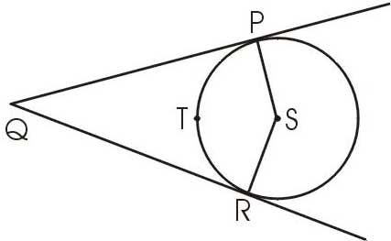
Points P and R are the point of contact. S is the center of the circle. If m(arc PTR) = 110⁰ then find ∠PQR.
- 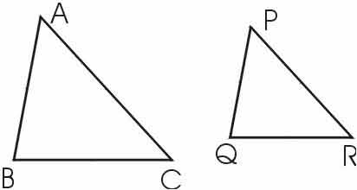
Area of 2 similar triangles ΔABC and ΔPQR are 36 cm² and 25 cm². If BC = 6.4. Find QR.
- 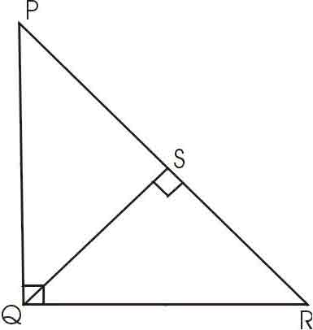
∠PQR = ∠QSR = 900. PS = 10 , QS = 8. Find SR.
- The diagonals of a rhombus are 24 cm and 10 cm. Find its area and perimeter.
- The volume of a cube is 1000 cu.cm. Find the total surface area.
- 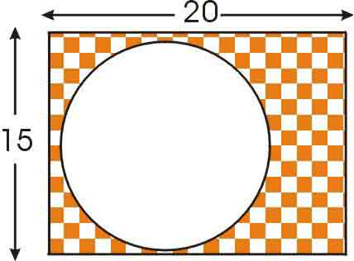
Find the radius of the circle shown in the figure, if the area of shaded region is 124 cm².
- Mayur bought a shirt of Rs. 583/- which included 6% sales tax.
- Find list price of the shirt.

SECTION - B.

Question 16 to 25 carry 4 marks each.

- Find the missing figure :
Class | 00 - 20 | 20 - 40 | 40 - 60 | 60 - 80 | 80 - 100
Frequency | 17 | 28 | 32 | - | 19
- Simplify graphically the following system of linear equations.
- 3x - 4y = 12.
- 6x - 3y = 18.
- Construct a ΔABC in which AB = 4.4 cm , ∠C = 60⁰ and the median
- through C equals 3.5 cms.
- Solve ( a + b + c )( ab + bc + ca ) - abc.
- In an equilateral ΔABC , the side BC trisected at D . Prove that 9AD² = 7AB².
- If CosA / CosB = m and CosA / SinB = n
- Show that ( m² - n² ) Sin²B = n².
- Calculate the cost of living index number for the year 2000 taking 1996 as
- the base year from the following data.

Commodity | Quantity | Price in units(Rs.)  1996 2000
A | 10 | 8.00 | 12.00
B | 15 | 6.00 | 8.00
C | 12 | 5.00 | 6.50
D | 20 | 4.00 | 55.00
E | 25 | 15.00 | 20.00
- 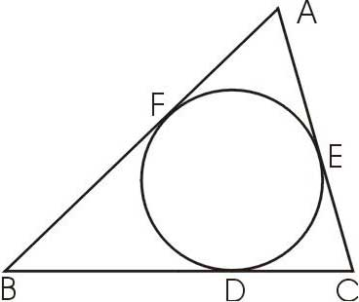
In the given figure the incircle of ΔABC, touches the side BC, CA and AB at D ,E and F respectively. Show that AF + BD + CE = AE + BF + CD = 1 / 2 (perimeter of ΔABC )
- Two isoselas traingles have equal vertical angles and their area are
- in the ratio 9:16. Find the ratio of their corresponding heights(altitudes)
- How many bricks each of dimension 25cm x 16 cm x 10 cm will be needed to build
- a wall 24 meters long, 6m height and 4m thick. What will be the cost of bricks at the rate of
- Rs. 3.50 per 1000 bricks, 10% of the wall is filled with mortar.

SECTION - C.

Question 26 to 30 carry 6 marks each.
- The angle of elevation of top of a tower from two points at a distance 'a'
- and 'b' from the base and in the same straight line with it are complementary.
- Show that the height of the tower is √ab.
- 2(x² + 1 / x²) - 3(x + 1/x )-1 = 0.
- 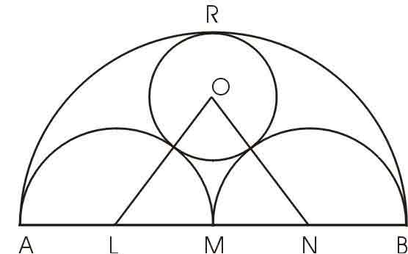
AB is a line segment and M is its mid point on one side of AB, semi-circles have been drawn by taking AM, MB and AB as diameters. A circle has been drawn which touches each of the 3 semi-circles. Prove that the radius of circle = 1/6 AB.
- During the year 1998-99, Mr. Sharma's income was Rs. 8300/- per month (HRA not included )
- He contributes Rs. 9200/- towards PF during this year Rs. 100/- are deducted each month
- for 11 months from his salary as income tax. How much should invest in NSC so that he need
- not to pay any more tax in the last month of the year.
- 2 digit no. is such that the product of digit is 8, when 63 is subtracted from the no. the digits
- interchange their places. Find the number.

